Note: Restoring a project Backup

Product: MachineShop Toolbar

Date: 10/19/2000

Application Note
While precautions have been taken in the preparation of this note, CTC and the author assume no responsibility for errors or omissions. Neither is any liability assumed for damages resulting from the use of the information contained herein.

Restoring A Project Backup Using the MachineShop Toolbar

To create a project backup in Interact or MachineLogic using the MachineShop Toolbar go to the MachineShop Toolbar and Select the Restore Project Icon or go to Tools and select Restore Backup and then select Project.

The Restore Wizard box will appear and then ask you where the backup files are located that you want to restore. The default path should be C:\MachShop\Backups. Select the components that you want to restore and then click Next to continue.

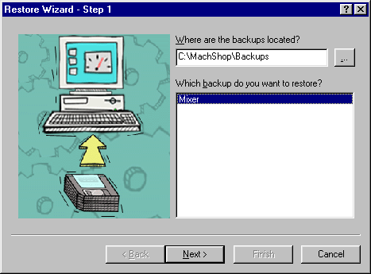

The next step is to select the components of the project you want to restore. Make sure everything is correct and click on Finish to restore the backup. Note: You should not include Runtime Program Files if you are unsure of the Version the project was created in. Also if you are not using MachineLogic there is no need to check MachineLogic Source Backup.

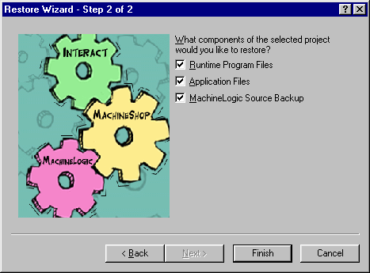

The Restore Project Information box will appear. Make sure everything is correct and select OK to continue.
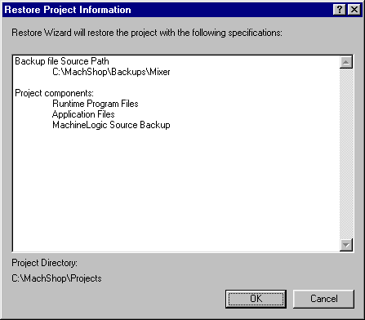

If the project that you are trying to restore already exsists on the PC you may get the message seen below. If so click Yes to continue or No to abort the restoration.

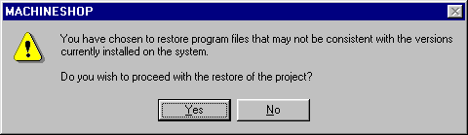

If you chose Yes the following box will appear prompting you to either rename the project or delete the existing project and restore the backup in its place. To delete the existing project and restore the backup in its place select Restore. To rename the back-up project and keep the existing project as it is select Rename. To abort the restoration click Cancel.

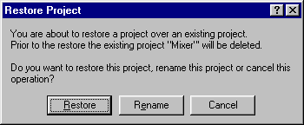

If you chose rename the Rename box will appear. Enter a new name to change the restoration too and then select OK.

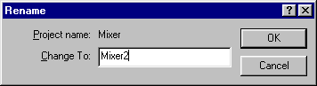

When the restoration is complete you will see the Restore Complete box. Click Close to finish the restoration.

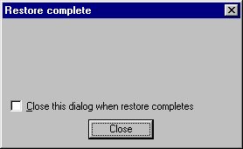

After the restoration is done the Current Project should be the name of the project you restored.

